## 

Table of Contents

1. Executive Summary 2

2. Objective 2

3. External Analysis 3

3.1. Value Proposition 3

3.2. Porters 5 Forces 4

4. Scenario Planning 6

4.1. STEEPLE Analysis 7

5. Recommendations 8

5.1. Reputation on Safety 8

5.2. Improving Software 9

5.3. Partners 9

6. Conclusion 10

7. Bibliography 10

## *Executive Summary*

In January 2015, there were 70 thousand trips per day using ride-sharing platforms and more than 450 thousand taxi rides. In July 2018, tables turned, and trips per day number were 550 thousand for ride-sharing and 300 thousand for taxi rides. In just three years, ride-sharing apps increased their number by 780% while taxis decreased by 33% (Waghmare, 2019). Ride-sharing apps certainly disrupted the taxi industry.

On top of these apps, there is Uber with a 70% market share with Lyft following by 28% (Waghmare, 2019). Uber's market share has been declining due to new competitors and scandals, both internal and external and although the problems are solved, customers still remember them.

While ride-sharing apps scale up, they become more vulnerable to safety concerns and regulations, it happened once, and it should not happen again. Uber, as a platform, should get safer and be known for that.

With autonomous cars improving and used as transportation, there is a new era of traffic in front of us and, Uber has to be ready for it.

This report will go into detail for every one of these problems and future predictions.

## Objective

This report includes

* External analysis of the market for Uber using Porter's five forces framework and value proposition comparison, which will explain the market Uber is in and give comparative data between Uber and its competitors.
* Using the STEEPLE framework, I will explain possible future scenarios Uber can face, how it should act in these situations, and prepare for them.
* In the recommendations part, I will include present and future activity suggestions towards creating more value for the brand, safer and more modern platform using available technologies to better compete with its competitors.

## *External Analysis*

Deciding how to respond to different situations in the present or the future, first, we have to know the market. Uber's competitors are not just other ride-share apps like Lyft but also taxis, buses/trains, and rental car services.

### Value Proposition

Ride-share apps are very similar to each other, and including Lyft in value proposition would not give valuable output because of that reason. So, I will compare ride-share apps with other competitors.

You can see the value proposition table in the following:

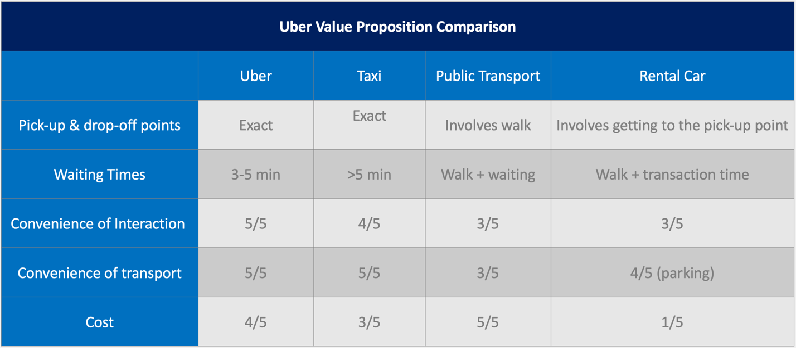

As can be seen from the value proposition Uber is the perfect choice for people who wants point to point transportation for in-city distances. It is cheaper and easier to find than a taxi, more convenient than public transport, and much cheaper than a rental car. As a representor for ride-share apps, Uber is the best choice for many potential customers.

### Porters 5 Forces

Porters 5 forces framework will help us understand the industry and its interests and identify opportunities and risks. Five forces are

* Bargaining power of buyers,
* Bargaining power of suppliers
* Threats of new entrants
* Threat of substitutes
* Rivalry among existing competitor (Uenlue, 2018)

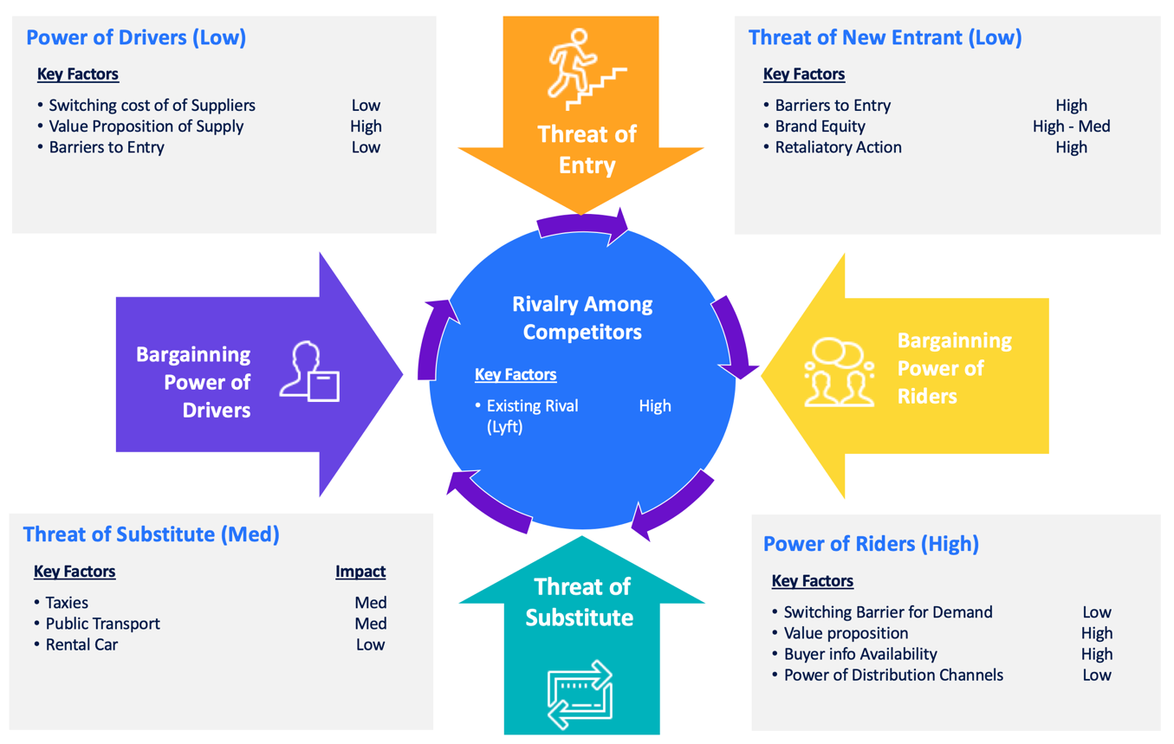

1. Bargaining Power of Riders (High): There are many strong competitors for customers to switch.

Switching Barrier for Demand (Low): Customers don't have any barrier to shift, many are using multiple of them at the same time.

Value Proposition (High): As can be seen in 3.1, ride-sharing apps have the edge over competitors.

Buyer information availability (High): There is a good chance if someone knows Uber, they also know Lyft and public transportation.

Power of Distribution Channels (Low): Uber is an app like its competitors, and because buyer info is high too, there is hardly any difference between channels.

* 1. Bargaining power of Drivers (Low): There is no shortage of drivers, and without any union on their side, it is impossible to demand anything.

Switching Cost of Suppliers (Low): Drivers can use multiple platforms at the same time, there is no cost of switching.

Value Proposition of Supply (High): App directs drivers to customers, which means less time idling, more time making money.

Barriers to Entry (Low): It is straightforward to join Uber as a driver, decreasing the bargaining power of drivers; anyone can join with ease.

* 1. Threats of New Entrants (Low)

Barriers to entry (High): Although it is elementary to develop an app and get a small number of drivers, it is tough to scale it up and compete with Uber or Lyft. There has to be something disruptive about it to gain market space.

Brand Equity (High – Med): It is not perfect at this time, but in the long run, Uber brand is a significant asset.

Retaliatory Action (High): Without a doubt, Uber will try to block new entries by entering new cities and complementary areas such as freight and meal delivery, which will discourage investors from supporting new entries.

* 1. The threat of Substitutes (Med)

As seen in the value proposition table (3.1), substitutes as rental cars and public transport have different value propositions and customer targets. Uber's target customer does not want to drive, wants exact pick-up and drop-off points, and easy convenience. Taxi is the closest substitute, and Uber beats it with being cheaper and more convenient.

* 1. Rivalry among Competitors (High)

In the New England area, the only competitor is Lyft, and it is gaining market share year by year. Lyft increased its market share by 15.8% from 2015 to 2018 and continues to do so with the help of scandals (Waghmare, 2019).

## Scenario Planning

The future for the transportation industry is going towards automation and self-driving cars. Subways and trains are already controlled by computers to be on time at all times rather than a conductor. Car companies are pivoting their focus from driver cars to passenger cars.

This shift towards driverless cars can cause many problems and opportunities in the transportation sector. Uber, as a tech and transportation company, has to be ready for these changes, lead them, and be quick adapting them.

#### Drivers

Transportation will inevitably go driverless. The software will drive the car, and their information will be available at all times to the company, there will be no room for human error. Drivers earning their living in this industry will be out of jobs. As of today, there are 3.9 million drivers just for Uber, with 50% of these drivers married, 46% have children, and 25% financially supporting parents or other relatives; a layoff of this magnitude will bring political and social problems with itself. Companies' revenue will increase because they will not be paying anything for drivers; therefore, they will try to push forwards through politics and regulations.

#### Technological

Studies show that over 50% of adults in the US, would not feel safe sharing the roads with driverless vehicles (Waghmare, 2019). Even though autonomous software is can technically competent enough to drive the car, even the best can run into problems and cannot be fully trusted. Software is an assistant rather than a driver. In the future, the software will get better and take the driver's role, but the public has to trust them too. More than 70% of adults in the US are in favor of regulations targeting driverless cars. Separate lanes and restricted areas are some of the proposed regulations (Waghmare, 2019) (Iqbal, 2019).

#### Ethical

In the event of an accident, the guilt side is the one who caused the accident. In the event of an accident involving an AV, who will be to blame, the manufacturer or the owner? The logical answer should be the manufacturer because the owner was a passenger. Governments have to draft regulations for these situations and the process can take time. During the time without regulations, companies should take responsibility, that is the ethical thing to do, but without any regulations, they won't have to. These situations can cause problems for the entire AV industry and stall innovation.

### STEEPLE Analysis

I will use the STEEPLE framework to analyze possible future environment scenarios further to give more accurate recommendations.

You can see the STEEPLE framework in the following graph.

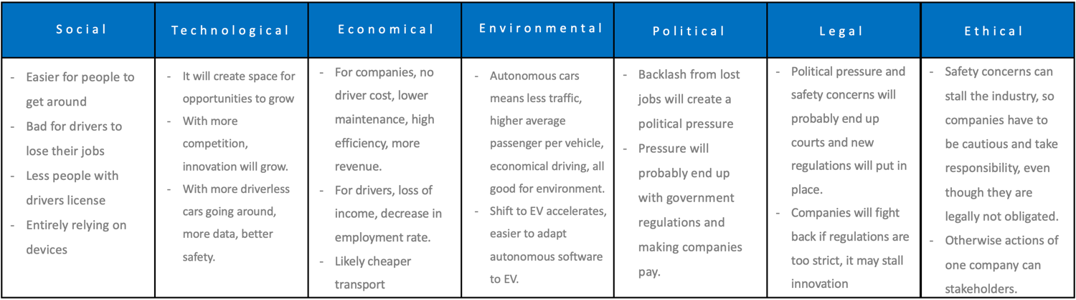

Driverless cars will alter the vehicle and transportation industry; the change is already here. They will create new opportunities and extinct some jobs. With all things considered Uber, should lead these changes, and without creating and backlash, they should be ethical in all areas.

## Recommendations

In the light of the information given previously, to goal for Uber is to increase its market share, known as a safe platform and be ready for future developments.

### Reputation on Safety

The main reason Uber is losing market value is scandals and sexual harassment issues stuck to it. Problems occurred internally and externally, and they are solved now, but Uber's reputation is still negative. Uber has to build its reputation again around safety and prove customers; it is a safe platform to use. Uber already added a panic button and other safety features, but it should be even better. It should protect not just the passenger but the driver as well.

Most Uber drivers have their phone in a holder in front of the car for navigation purposes. A "security camera" feature can be added recording with front and back-facing cameras and guarantee safety in the car and on the road. The front-facing camera will be activated at passenger pick up and record through travel, ensuring the safety of the driver and the passenger. The back-facing camera will record the road and guarantee that the driver is obeying the rules. All done in software, the cost will be minimal, and positives would be massive for safety and Uber's reputation.

### Improving Software

Some states and cities opened themselves up to limited and controlled testing of AVs, and Boston is one of them. Boston's roads are not perfect for AVs; in some places, lanes are not visible, the road surface is not even, and routes are all together complicated. Most of these problems caused by Boston being an old city and roads being repaired rather than renew. Nevertheless, AVs have to work in towns like Boston too. AV software needs petabytes of data to improve and understand every possible situation. Getting this data is only possible with driving around with AVs, but in a city like Boston, it would not be completely safe.

My recommendation is equipping cars with the software but as an observer. The software will use cameras and sensors to scan the road and make decisions as usual, but it will not execute them. It will compare the decision with the driver's action. If the decision is parallel with action, the decision is correct. By this process, driving around with an AV will not be more dangerous than driving an average car, and data will be collected.

### Partners

Car manufacturers led by Tesla have been working on AVs for a time now, and they are on the brink of fully autonomous driving. Tesla announced that with their self-driving cars, they will start a driverless taxi program while the vehicle is not in use. With this plan, Tesla will become a direct competitor for Uber. The problem Tesla will have is, they don't have the customer base as Uber. Uber should offer partnership and include Tesla taxis into their program. This step will get Tesla customers and Uber industry-leading AVs. It would be a win for both parties, and they would be partners instead of competitors.

With the help of these recommendations, Uber will increase its market share, repair its reputation by being as safe as possible, and prepared for the future.

## Conclusion

Ride-sharing apps disrupted the taxi industry, and AVs will disrupt it again among other industries using vehicles. Uber has to be prepared to lead this industry from day one by improving its software, implementing the software to their cars, and retrofitting existing cars to generate as much data as possible. It should create partnerships to turn their competitors into their partners, but before all that, Uber has to restore their reputation and be a company people trust not just with their software but their ethics as well. If Uber does all this and position itself correctly, it could be the biggest company on transportation.

## Bibliography

Iqbal, M. (2019, May 10). *Uber Revenue and Usage Statistics (2019)*. Retrieved from Business of Apps : https://www.businessofapps.com/data/uber-statistics/

Uenlue, M. (2018, March 18). *Strategy: Porter’s Five Forces explained*. Retrieved from Innovation Tactics: https://www.innovationtactics.com/porter-five-forces/

Waghmare, E. O. (2019). Autonomous Vehicles: Smooth or Bumpy Ride Ahead? *Harvard Business School*.